Conference Programme

DAY 1 – Wednesday 1st Sept 2021 – WELCOME FUNCTION

Crown Plaza Queenstown
18.30 – 18.35 | Welcome  Hesh Al-Sallami  President/Chair of ASCEPT NZ
18.35 – 19.30 | Registration opens. Drinks, nibbles, and networking function

DAY 2 – Thursday 2nd Sept 2021 – ANNUAL SCIENTIFIC MEETING
08.30 – 08.55 | Registration opens. Tea and coffee available
Welcome – Hesh Al-Sallami
Oral Communications 1 – Chair: Prof Michelle Glass
09.00 – 09.15 | (A1)  Synthesis of polymeric iNOS antagonist prodrug for targeted inhibition of inflammation induced angiogenesis  Houman Alimoradi  Department of Anatomy, Brain Health Research Centre, University of Otago  Brain Research New Zealand
09.15 – 09.30 | (A2)  From an unsuccessful phase III clinical vascular disrupting agent to a target based immuno-modulator, the rise of xanthenones  Jack Flanagan  Department of Pharmacology and Clinical Pharmacology, School of Medical Sciences, University of Auckland
09.30 – 09.45 | (A3)  Developing lipidated calcitonin gene related peptide (CGRP) peptide antagonists  Aqfan Jamaluddin  School of Biological Sciences, University of Auckland
09.45 – 10.00 | (A4)  An Old Drug with New Tricks; Examining the Action of Metformin in ALK+ Lung Cancer  Abigail Bland  Department of Pharmacology and Toxicology, University of Otago
10.00 – 10.15 | (A5)  Pharmacogenetics of omeprazole treatment for GERD  PS Kee  Department of Pathology and Biomedical Science, University of Otago, Christchurch
10.15 – 10.45 | Morning tea
Student Presentations 1 – Chair: Dr Katie Burns
10.45 – 11.00 | (A6)  A Before-After Study Comparing Area Under Curve with Trough Concentration Guided Vancomycin Dosing  Guangda Ma  Department of Pharmacology & Clinical Pharmacology, The University of Auckland
11.00 – 11:15 | (A7)  Clinical interventions to improve adherence to urate-lowering therapy in patients with gout: a systematic review  Klarissa Sinnappah  School of Pharmacy, University of Otago
11.15 – 11.30 | (A8)  Population pharmacokinetics and exposure-response analyses for allopurinol in patients with gout  Hailemichael Hishe  School of Pharmacy, University of Otago
11.30 – 11.45 | (A9)  A tool to identify imperfect adherence to allopurinol therapy  Natalia Smith Diaz  School of Pharmacy, University of Otago
11.45 – 12.00 | (A10)  Defining arrestin-mediated ERK phosphorylation of a cannabinoid receptor  Jamie Manning  Department of Pharmacology and Toxicology, University of Otago
Quickfire session – Chair: Assoc Prof Hesh Al-Sallami
12.00 – 12.30 | (A11)  Using Bayesian software to inform initial busulfan dose in adults receiving haematopoietic stem cell transplantation  Marie-Claire Morahan  Department of Clinical Pharmacology, Canterbury District Health Board, Christchurch
12.00 – 12.30 | (A12)  The dual benefits of 5HT₃ receptor antagonists in cancer therapy  Anita Barzegar-Fallah  Department of Pharmacology and Toxicology, University of Otago
12.00 – 12.30 | (A13)  Regulatory mechanisms of CGRP receptors are controlled by their C-terminal tails  Tyla Alexander  Department of Pharmacology and Toxicology, University of Otago
12.00 – 12.30 | (A14)  Novel thermoresponsive hydrogels (NTH) to prevent reactive gliosis after stroke  Mozammel Haque Bhuiyan  Center for Bioengineering and Nanomedicine, Faculty of Dentistry, University of Otago & Department of Anatomy, Brain Health Research Centre and Brain Research New Zealand, University of Otago
12.00 – 12.30 | (A15)  Novel mixed opioid agonists provide anti-addictive properties and reduced respiratory depressive effects  Brittany Scouller  Centre for Biodiscovery, School of Biological Science, Victoria University of Wellington
12.00 – 12.30 | (A16)  Assessing the pharmacogenomic landscape of adverse drug reactions in Aotearoa  Simran Maggo  Department of Pathology and Biomedical Science, University of Otago, Christchurch
12.30 – 13.20 | Lunch
Symposium – Adverse Drug Reactions, a testing issue –
Chair: Assoc Prof Matt Doogue
13.20 – 13.50 | (A17)  Genomic analysis of angiotensin converting enzyme inhibitor - induced angioedema.  Prof Martin Kennedy, University of Otago, Christchurch
13.50 – 14.20 | (A18)  Testing for dihydropyrimidine dehydrogenase deficiency in New Zealand to improve the safe use of 5-fluorouracil and capecitabine in cancer patients  Assoc/Prof Nuala Helsby, University of Auckland
14.20 – 14.50 | (A19)  Bradykinin-mediated angioedema: beyond ACE inhibitors  Dr Hillary Longhurst, Auckland District Health Board
14.50 – 15.10 | Panel Discussion – Studying ADRs in New Zealand
15.10 – 15.40 | Afternoon tea
Student Presentations 2 – Chair: Dr Jacqui Hannam
15.40 – 15.55 | (A20)  The effect of mandatory prescription indications for antibacterials  Lorna Pairman  Department of Medicine, University of Otago, Christchurch
15.55 – 16.10 | (A21)  Evaluation of the appropriateness of the prior for incorporation into therapeutic drug monitoring software – an application to Infliximab  Alexandra McLennan  Otago Pharmacometrics Group, University of Otago
16.10 – 16.25 | (A22)  Quantifying metabolic interactions between AMB-FUBINACA and pFPP  Webb, H.D.J.  Department of Pharmacology and Toxicology, University of Otago
16.25 – 16.40 | (A23)  A Tale of Two Peptides: Identifying Targets for Migraine  Rees, T.A.  School of Biological Sciences, University of Auckland, Auckland
16.40 – 16.55 | (A24)  Delineating the interactions between the type 2 cannabinoid receptor and its regulatory effectors, β-arrestin 2 and G protein-coupled receptor kinases.  Monica Patel  Department of Pharmacology and Toxicology, University of Otago
16.55 – 17.00 | Comfort Break
17.00 – 18.00 | ASCEPT AGM
19.00 | Conference dinner  Blue Kanu, 16 Church Street, Queenstown

CONFERENCE DINNER
Blue Kanu (https://www.bluekanu.co.nz/) is a short walk from the Crowne Plaza (~400 m or 5 min).

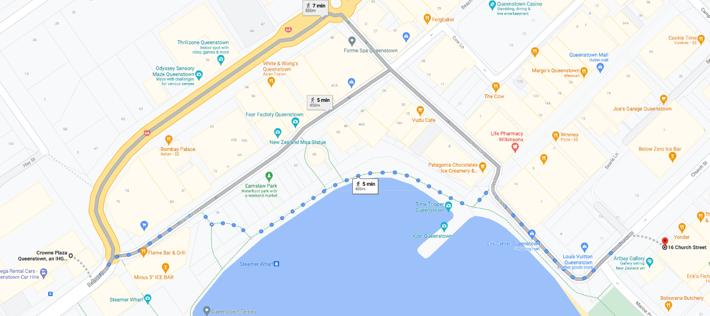
Blue Kanu
Conference location

DAY 3 – Friday 3rd Sept 2021 – ANNUAL SCIENTIFIC MEETING
Invited Speaker – Chair: Assoc Prof Ivan Sammut
09.00 – 09.30 | (A25)  A new hope: Calcitonin gene-related peptide blocking drugs in migraine  Prof Debbie Hay  Department of Pharmacology and Toxicology1, University of Otago, Dunedin
Student Presentations 3 – Chair: Assoc Prof Nuala Helsby
09.30 – 09.45 | (A26)  Prophylactic organic carbon monoxide donors protect hypertrophic hearts against ischaemia-reperfusion injury  SH Thwaite  Dept of Pharmacology & Toxicology, School of Biomedical Sciences, University of Otago
09.45 – 10.00 | (A27)  An insight into the positive inotropic effects of CO release by oCOm-21  Fergus Payne  Department of Pharmacology and Toxicology, University of Otago
10.00 – 10.15 | (A28)  Cefazolin pharmacokinetics during cardiac surgery supported by cardiopulmonary bypass  Conor O’Hanlon  Department of Pharmacology and Clinical Pharmacology¹, University of Auckland
10.15 – 10.30 | (A29)  Clozapine-associated Perturbation of Arachidonic acid Metabolism – An Investigation into Clozapine-induced Cardiotoxicity  Ellen Kingston  Department of Pharmacology and Clinical Pharmacology, University of Auckland
10.30 – 11.00 | Morning tea
Student Presentations 4 – Chair: Assoc Prof Matt Doogue
11.00 – 11.15 | (A30)  Population pharmacokinetics of oxycodone: premature neonates to adults  James Morse  Department of Pharmacology and Clinical Pharmacology, University of Auckland
11.15 – 11.30 | (A31)  The effect of combining a SHP2 inhibitor and ALK inhibitor on ALK-positive non-small cell lung cancer cells  Madeleine Berry  Department of Pharmacology and Toxicology, University of Otago
11.30 – 11.45 | (A32)  Mechanistic Action of Spiroleucettadine in Non-Small Cell Lung Cancer Cells  Ben Watts  Department of Pharmacology and Toxicology, University of Otago
11.45 – 12.00 | (A33)  In vitro characterisation of ZCZ-011 at the type 1 cannabinoid receptor: allosteric agonist or allosteric modulator?  Hayley Green  Department of Pharmacology and Toxicology, University of Otago
12.00 – 12.15 | (A34)  Optimal insulin initiation dose in children with type 1 diabetes mellitus  Isabelle Lim  Otago Pharmacometrics Group, University of Otago
12.15 – 13.10 | Lunch
ASCEPT Guest Speaker – Chair: Assoc Prof Hesh Al-Sallami
13.10 – 13.40 | (A35) via Zoom  Adverse Drug Reactions in Older Adults  Assoc Prof Danijela Gnjidic  School of Pharmacy, Faculty of Medicine and Health, University of Sydney
Oral Communications 2 – Chair: Assoc Prof Malcolm Tingle
13.40 – 13.55 | (A36)  A survey of 6-thioguanine use by gastroenterology clinicians for inflammatory bowel disease  Murray Barclay  Department of Clinical Pharmacology, Christchurch Hospital, University of Otago
13.55 – 14.10 | (A37)  Extracellular bimolecular fluorescence complementation assays for investigating receptor dimerization: a proof of concept with receptors for calcitonin gene-related peptide  Michael Garelja  Department of Pharmacology and Toxicology, University of Otago
14.10 – 14.25 | (A38)  Investigating the signalling of an atypical group of receptors – GPCR-PIPK bigrams  Gabriel Rawcliffe  Department of Pharmacology and Toxicology, University of Otago
14.25 – 14:55 | Conference Close and Prize Giving  “In memory of Prof Fred Fastier”

