Te Whanaketanga Puutaiao Maaori Summit
Saturday 31st August, Rydges Hotel, Queenstown

SPEAKERS
Dr Phillip Wilcox (BForSci(Hons)(Cant) PhD(Nth Carolina > SU) DipTeAraReoMāori(Te Wananga o Aotearoa)) is of Ngāti Rakaipaaka, Rongomaiwahine, Ngāti Kahungunu ki te Wairoa.
Phil specialises in Quantitative genetics, applied genomics, breeding, medical genetics, Māori engagement.

He is Senior Lecturer in the University of Otago’s Department of Mathematics and Statistics, and has experience in applied genomics and statistical genetics. He is the current convenor of MapNet, a NZ-wide collective of gene mapping scientists and the Project Leader of the Virtual Institute for Statistical Genetics. He is formally a Kaihautu Maori in both the Biological Heritage National Science Challenge and the BioProtection Research CoRE, and is a mandated spokesman for Ngati Rakaipaaka regarding the Rakaipaaka Health and Ancestry Study. He has worked on genetics of plant species (particularly forest trees) and humans diseases.

Phil is Convenor and speaker at this year's Summit.
Phil will be speaking on Genomics Science Interface Puutaiao Maaori
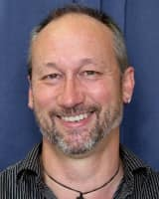

Irene Kereama-Royal, LLM Masters of Māori, Pacific and Indigenous Rights Law. (1st Class Honours).

Irene is of Ngāpuhi and Parehauraki descent. She is a member of the Royal Society of NZ’s expert panel on gene editing technologies with interests in genomic research, diagnostics and treatments for familial diseases, particularly cancers. Irene is a Researcher at Ngā Wai a Te Tūī Māori Research Centre at Unitec Auckland.

Irene will be speaking on Maaori participation in medical genomics research.
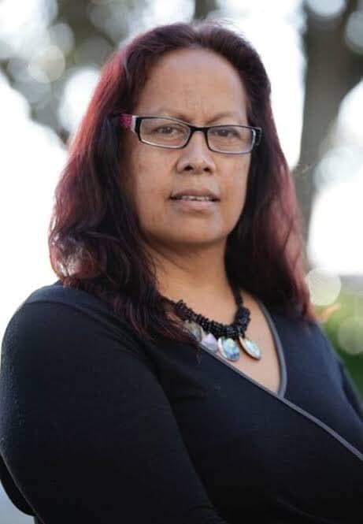

Mr Karaitiana Taiuru of Ngāi Tahu (Koukourarata, Puketeraki, Rāpaki, Taumutu, Tuahuriri, Waewae, Waihao, Waihopai, Wairewa); Ngāti Rarua; Ngāti Kahungunu (Ngāti Pahuwera); Ngati Hikairo (Ngati Taiuru); Tūwharetoa (Ngāti Tamakopiri); Ngāti Hauiti (Ngati Haukaha); Ngāti Whitikaupeka.

Having an accomplished career in the technology industry where representing Māori and Indigenous Rights, Mr Karaitiana Taiuru is currently a PhD Student at Te Whare Wānanga o Aotearoa researching IP rights and tikanga Māori with gene research.
Karaitiana will be speaking on Cultural and Intellectual Property Tikanga considerations’ “What does the tikanga interface look like and how will it be applied?
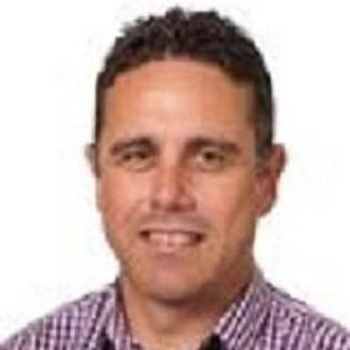

Benjamin Iwikau Te Aika is of Ngati Mutunga, Te Ati Awa, Kati Wairaki, Kati Mamoe, Waitaha. Passions are children, hunting, whakapapa and whenua.
Specialist in Māori economic development in environmental advocacy.

A Māori artist, carver, taa moko. Currently Vision Mātauranga Coordinator at Genomics Aoteraoa.

Ben will be speaking on Genome Sequencing/Data protections
What should culturally appropriate genomic data protection look like for indigenous species, data sovereignty?
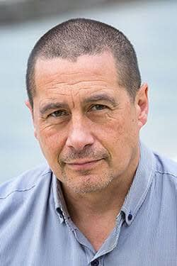

Dr Kimiora Henare (Te Aupouri, Te Rarawa), (PhD, MHSc, BSc) is a Research Fellow at the Auckland Cancer Society Research Centre (ACSRC), Te Kupenga Hauora Māori, and the Department of Oncology at the Faculty of Medical & Health Sciences, University of Auckland. His research interests include cancer biology and immunology.
Kimiora will be speaking on Tikanga Maaori in the Lab.
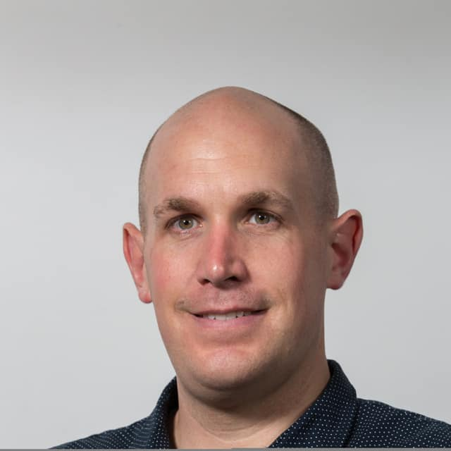

Nau mai haere mai.

